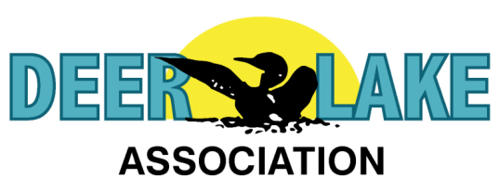
Deer Lake Station
Deer Lake Station serves to help prevent the introduction and limit the spread of aquatic invasives (AIS) in Itasca County. Zebra mussels, starry stonewort, spiny water-flea, Eurasian milfoil, and other aquatic invasives negatively impact the fishery and substantially degrade water quality.
The Station provides tools to help boaters accomplish Clean, Drain, Dispose, and Dry as required by law. Arriving and departing boaters can use well-water and hand-tools to clean mud, weeds, and flush standing water from boats, trailers, and recreational gear that otherwise may transport AIS from one lake or river to another. The Station includes access to cold exchange water for bait, and lights to enable boaters to perform clean, drain, dispose, and dry 24/7. Use of the Station is free of charge.
Deer Lake Station also provides tools for use only by the Itasca AIS Program and other authorized DNR certified professionals, including access to low-flow and high pressure decontaminating hot water. 140° hot water will kill AIS when applied properly for 10 seconds. 120° hot water will kill AIS when applied for 2 minutes.
The Station was constructed by local skilled contractors. We are grateful to Fideldy Brothers Well-drilling, S&S Excavating, Deer River Plumbing and Heating, Pokegama Electric, and Lake Country Power for their work and expertise. Station construction was funded by the Deer Lake Association along with an award from the Itasca AIS Community Action Projects matching grant program.
Almost always, new lakes and rivers are infested unwittingly. Aquatic invasives are not moved by waterfowl or other wildlife. AIS are moved by us. We move AIS from one lake or river to another via boats, trailers, bilge, live-well, bait-container, fishing gear, docks, lifts, swim-rafts, float planes, and recreational gear. We all have a prevention role … property owners, recreational boaters, anglers, guests, visitors, and the businesses that service us, including lake service providers, marine dealers, resorts, camps, campgrounds, bait-shops, rental shops, and other similar businesses.
Anglers, recreational boaters, property owners, guests, and visitors can help prevent new AIS infestations by practicing Clean, Drain, Dispose, and Dry. When you land your boat, thoroughly inspect it. Remove weeds and mud. Drain standing water. Empty live-wells and bait-containers on shore. Know what lakes contain which AIS. If the waters you’re exiting include AIS, dry your boat in the sun for at least five days before launching in another lake. If you don’t have five days, decontaminate your boat and trailer before launching.
The Itasca AIS Program will decontaminate your boat for free. Call 218-256-4243 for decontamination station location closest to you.
For a specific comprehensive description for what boaters, anglers, and lake and river property owners and guests can do to prevent the spread of AIS, see http://bit.ly/AISItasca

